Topology & PING

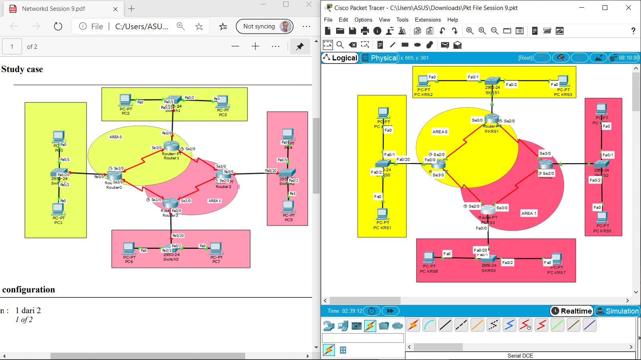1. Topology

2. Verify connection with ping from all PC that connected through different router.

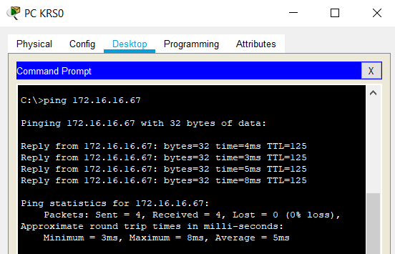**- PC KRS0 ke PC KRS4**

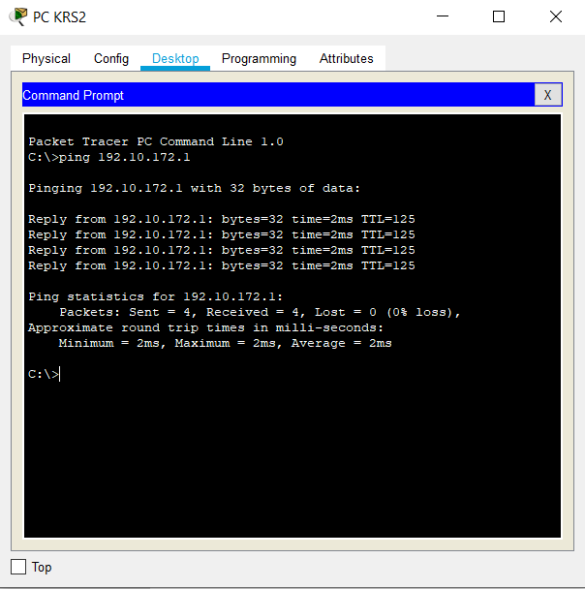**- PC KRS2 ke PC KRS6**

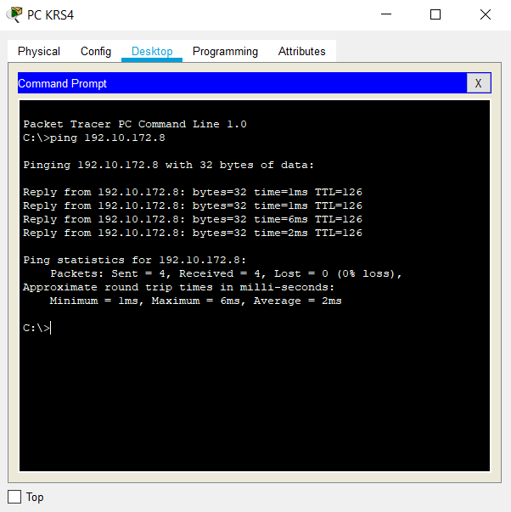**- PC KRS4 ke PC KRS7**

**- PC KRS6 ke PC KRS1**

